CNRC Letter of Commendation for DEPpers/New Recruits
(For Qualified New Contracts)

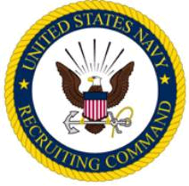

The Commander Navy Recruiting Command takes pleasure in commending

RANK/RATE
FNAME MI LNAME
UNITED STATES NAVY

for service as set forth in the following

-CITATION-
For commendable achievement in the performance of his/her duties while serving in the Delayed Entry Program at NRD BLANK from Month Year to Month Year. Rate Lname was responsible for the enlistment of four qualified new contracts who enlisted into the Navy from the City, ST area. By his/her outstanding efforts and enthusiasm, Rate Lname has demonstrated exceptional potential for a successful Naval career. Rate Lname‘s performance was in keeping with the highest traditions of the United States Naval Service.

J. F. KILKENNY
RDML, U.S. Navy

